SIMATS ENGINEERING (SAVEETHA SCHOOL OF ENGINEERING)
Department of Computer Science and Engineering
ASSESSMENT TOOL 2– Case Study (2 QUESTIONS)

Course Code: | ITA05 | Course Title: | COMPUTER VISION
CO Assessed: | CO3 – Precision (BL4) | Assessment: | Assessment Tool 1 – Case Study
Weightage: | 40% of CIA | Total Marks: | 20 (2 Questions × 10Marks)
CO1 Statement: | Analyze and extract image features using detection and matching techniques for effective image representation and comparison..(BL4)
Student Name: | S . Adhi Kesavan | Reg. No.: | 192521172
Section / Batch: | Slot D | Date:

Code of Conduct
I S.Adhikesavan-192521172 (Name / Reg No) certify that this submission is my original work and that I have adhered to the guidelines specified for this assessment. I understand that any violation of academic integrity rules will result in disciplinary action.

Signature of the Student: _________________________

Instructions
- This test contains 2 questions, each carrying 10 marks. Total: 20 Marks.
- No negative marking. Unanswered questions carry zero marks.
- No calculators or electronic devices permitted.
- Duration: 60 minutes.

Section / Topic | Focus | Q Nos | Marks
Feature Detection and Matching | Preprocessing, Edge Detection, Harris Corner Detection, Hough Transform, SIFT | 1 | 10
Feature Detection and Matching | PCA, Image Representation, Feature Matching, Image Processing Applications | 2 | 10
GRAND TOTAL: |  | 20 Marks

Annexure A –Case Study

1.A remote sensing application is used to align satellite images of the same geographical region captured at different times for monitoring environmental changes. The system initially relies on edge detection to identify matching regions between the images; however, due to differences in illumination, image orientation, and background details, the matching process becomes unreliable and produces inaccurate alignment results. The development team decides to replace the edge-based approach with Harris Corner Detection to identify stable and distinctive feature points. Analyze the limitations of edge detection in this application and explain how Harris Corner Detection improves feature localization, matching accuracy, and robustness for image registration under varying imaging conditions.

2.An autonomous surveillance system continuously captures high-resolution color images to detect vehicles and pedestrians in real time. Processing the original color images directly increases computational complexity and slows down feature extraction, making it difficult to achieve the required processing speed. To improve system performance, the engineers consider converting the images into grayscale or binary representations before applying feature detection algorithms. Analyze the impact of different image representations on computational efficiency, edge detection, and feature extraction performance, and justify the most appropriate image representation for achieving accurate and reliable object detection in real-time computer vision applications.

Solution :

1. Harris Corner Detection for Remote Sensing Image Registration
Introduction

In remote sensing, satellite images of the same geographical region may be captured at different times. These images are used for applications such as deforestation monitoring, urban development, flood analysis, agricultural monitoring, and environmental change detection.

For accurate comparison, images captured at different times must first be registered/aligned. Initially, edge detection may be used to find common features. However, edges are often unstable when images have different illumination, orientation, scale, or background information. Harris Corner Detection provides more distinctive and localized feature points, making it more suitable for image registration.

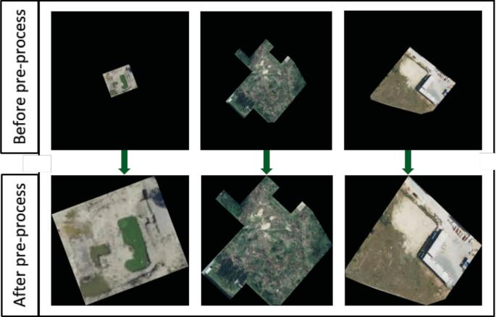
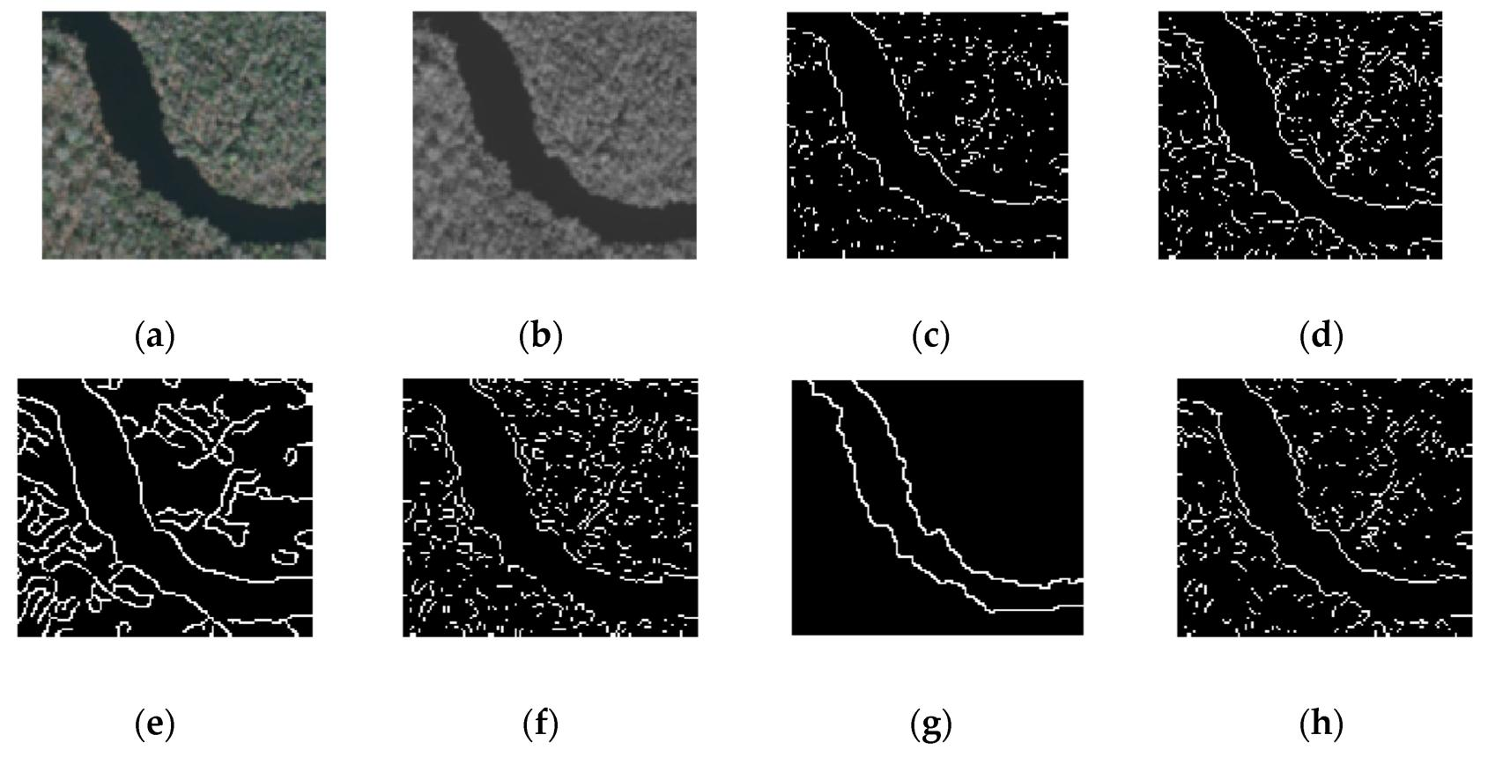
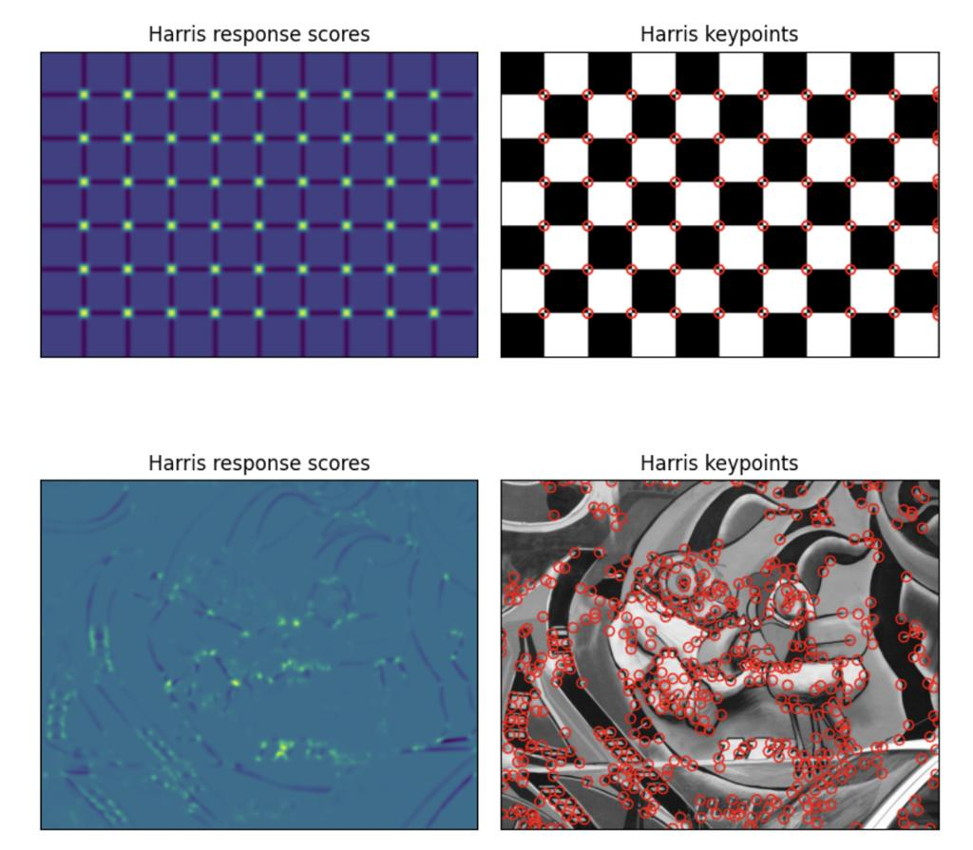

Limitations of Edge Detection

Edge detection identifies locations where there is a significant change in image intensity. Techniques such as Sobel, Prewitt, and Canny can detect boundaries of roads, buildings, rivers, forests, and other objects.
However, edge-based registration has several limitations:

1. Edges are not highly distinctive
An edge generally represents a boundary rather than a unique point. Many different objects can have similar edges.
For example, roads, building boundaries, and water boundaries may all produce similar edge patterns.

2. Sensitivity to illumination
Satellite images captured at different times may have different:
- Sunlight conditions
- Shadows
- Atmospheric effects
- Brightness
- Contrast
These changes can cause edges to appear stronger or weaker.

3. Background interference
Vegetation, clouds, shadows, and other background structures can produce additional edges. These unwanted edges make correspondence between two images difficult.

4. Poor localization for matching
An edge is usually a line or contour, not a unique point. Therefore, determining exactly which point on one edge corresponds to a point in another image can be difficult.

5. Orientation changes
If the satellite images have different orientations, the same object may produce differently positioned edge structures. Simple edge matching may therefore fail.

6. Noise sensitivity
Noise can generate false edges. This is particularly problematic in high-resolution remote sensing images.

Harris Corner Detection
Harris Corner Detection identifies corners, which are points where image intensity changes significantly in more than one direction.
A corner is generally more distinctive than a simple edge.
For example:
- A straight road boundary → mainly an edge
- Intersection of two roads → corner
- Building junction → corner
- Sharp boundary intersection → corner

Working Principle
The Harris detector examines how the image intensity changes when a small window is shifted in different directions.
The image gradient is calculated using:
These gradients are used to construct the structure tensor:
The Harris response is calculated as:
where:
- = Harris corner response
- = empirical constant, usually around 0.04–0.06
- = determinant of the matrix
- = trace of the matrix
A large positive generally indicates a corner.
How Harris Improves Image Registration

1. Better feature localization
Harris detects specific points rather than long continuous edges.
For example, a building corner can be represented by a specific coordinate:
This makes correspondence between images easier.

2. More distinctive features
Corners contain intensity changes in multiple directions. Therefore, they are generally more unique than individual edge points.
This helps the system identify:
Corner in Image 1 → Corresponding corner in Image 2

3. Improved matching accuracy
Once Harris corners are detected, corresponding points can be identified between the two satellite images.
The matched points can then be used to calculate a transformation such as:
- Translation
- Rotation
- Affine transformation
- Perspective transformation
The images can subsequently be aligned using the estimated transformation.

4. Better resistance to illumination variations
Harris detection is based on local intensity gradients and structural changes rather than simply relying on whether an edge is present.
Therefore, stable structural points such as building corners and road intersections can remain useful even when brightness and contrast change.

5. Robustness against background details
Instead of matching every edge produced by vegetation, shadows, and background structures, the system can focus on stronger corner points.
This reduces the number of irrelevant features.

6. Useful under orientation changes
Corners provide localized two-dimensional structures. When the image undergoes rotation, the same structural points can still be identified, although the classical Harris detector itself is not fully rotation invariant and may need additional feature handling for large rotations.

Edge Detection vs Harris Corner Detection

Feature | Edge Detection | Harris Corner Detection
Detects | Boundaries/edges | Corner points
Feature localization | Relatively poor | Very good
Distinctiveness | Low to moderate | High
Matching | Difficult for long edges | Easier using point correspondences
Illumination changes | Can be affected significantly | More useful for stable structural points
Background interference | High | Lower when strong corners are selected
Registration suitability | Limited | Better
Computational requirement | Generally low | Moderate
Feature type | 1-D structure | 2-D structure

Registration Process Using Harris
A typical registration system can follow these steps:
Satellite Image 1
↓
Preprocessing
↓
Harris Corner Detection
↓
Feature Points

Satellite Image 2
↓
Preprocessing
↓
Harris Corner Detection
↓
Feature Points
Then:

Feature Matching
↓
Corresponding Point Pairs
↓
Transformation Estimation
↓
Image Warping
↓
Registered Image

Conclusion

Edge detection is useful for identifying object boundaries, but it is not ideal as the primary feature representation for satellite image registration because edges are less distinctive and can be affected by illumination, noise, shadows, and background changes.

Harris Corner Detection provides localized and distinctive feature points, such as building corners and road intersections. These points improve feature correspondence and transformation estimation, resulting in more accurate image registration.

Therefore, replacing an edge-based approach with Harris Corner Detection is a suitable improvement for remote sensing image registration, particularly when stable structural features are available.

Solution 2 :

2. Image Representation for Real-Time Object Detection

Introduction
An autonomous surveillance system continuously captures high-resolution color images for detecting vehicles and pedestrians. Processing RGB color images directly requires more data and computational operations.
Therefore, the system can convert images into:

- Color/RGB representation
- Grayscale representation
- Binary representation

The choice of representation affects:

- Computational efficiency
- Memory requirements
- Edge detection
- Feature extraction
- Object detection accuracy
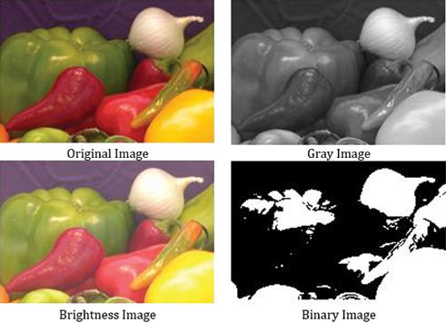
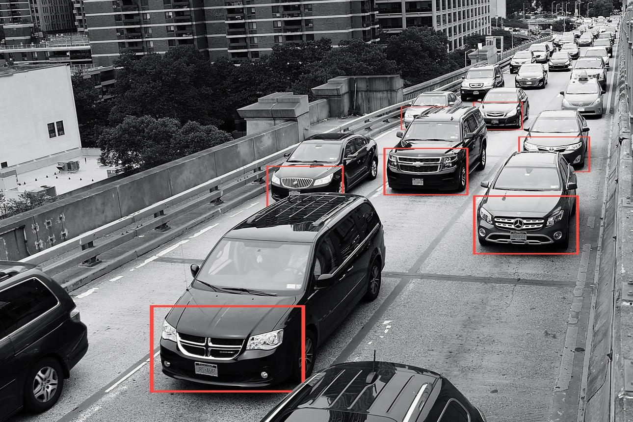
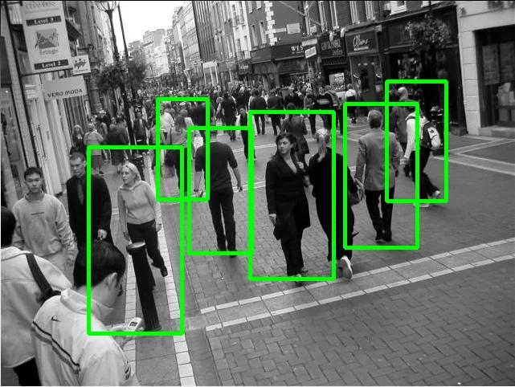
6

1. Color Image Representation
A typical RGB image contains three channels:
- Red
- Green
- Blue
For an image of width and height , the approximate amount of pixel data is:
because every pixel contains three color values.

Advantages
Color provides important information about objects.
For example:
- A red vehicle can be distinguished from its background.
- Road signs can be identified using color.
- Clothing color can help distinguish pedestrians.
- Vehicles with different colors can be separated.

Disadvantages
Processing three channels requires more:
- Memory
- Computation
- Storage
- Feature extraction operations
For high-resolution real-time video, this can reduce processing speed.

2. Grayscale Representation
A grayscale image contains only one intensity channel.
A common conversion is:
where , , and represent the red, green, and blue components.
Instead of three values per pixel, only one intensity value is required.

Advantages
Reduced computational complexity
Only one channel needs to be processed.
Therefore:
while:
This reduces the amount of data that feature detection algorithms must process.

Faster edge detection
Most edge detection algorithms operate primarily on intensity information.
For example:
- Sobel
- Prewitt
- Canny
can be directly applied to grayscale images.

Effective feature extraction
Many shape-based features depend primarily on intensity rather than color.
Examples include:
- Corners
- Edges
- Contours
- Texture
- Shape boundaries
Therefore, grayscale images are highly suitable for traditional computer vision algorithms.
Disadvantages
Color information is lost.
Two objects with similar brightness but different colors may become difficult to distinguish.
For example:
A red car and a gray car may have similar grayscale intensity under certain lighting conditions.

3. Binary Image Representation
A binary image contains only two values:
or commonly:
The conversion can be performed using thresholding:
where is the threshold.

Advantages
Very low computational requirement
Only two possible pixel values exist.
This makes:
- Storage efficient
- Processing fast
- Segmentation simple

Simple shape analysis
Binary images are useful for:
- Contour detection
- Connected component analysis
- Object segmentation
- Shape analysis

Disadvantages
Binary representation loses a large amount of information.
It removes:
- Detailed intensity information
- Texture
- Subtle boundaries
- Shadows
- Fine object features
Therefore, binary images can be unreliable when detecting objects in complex environments.

Comparison of Image Representations
Feature | RGB/Color | Grayscale | Binary
Channels | 3 | 1 | 1
Data size | High | Low | Very low
Computational complexity | High | Low | Very low
Color information | Preserved | Lost | Lost
Edge detection | Good | Excellent | Depends on threshold
Texture information | High | Moderate/High | Very low
Shape information | High | High | High for segmented objects
Feature extraction | Rich but expensive | Efficient | Limited
Noise sensitivity | Moderate | Moderate | High if threshold is poor
Real-time suitability | Moderate | High | High for simple scenes
Object detection accuracy | Potentially highest | Usually good | Can be poor in complex scenes

Impact on Edge Detection
RGB
Applying edge detection separately to three color channels increases processing requirements.
The system may need to calculate gradients for each channel and combine the results.
Grayscale
Grayscale is generally the most convenient representation for traditional edge detection.
For example:
RGB Image
↓
Grayscale Conversion
↓
Gaussian Filtering
↓
Canny Edge Detection
↓
Object Features

This provides good edge information with considerably less computation.
Binary
Binary images already contain strong intensity transitions between foreground and background.
However, if the threshold is incorrectly selected, important object boundaries can disappear.
For example:
Poor threshold → Missing vehicle boundary → Incorrect detection

Impact on Feature Extraction
Feature extraction algorithms identify useful information such as:
- Corners
- Edges
- Contours
- Texture
- Shape
RGB
Provides the maximum amount of information but requires greater computational resources.

Grayscale
Provides a good balance between information and computational efficiency.
It is particularly useful for:
- Harris corners
- SIFT-type intensity features
- HOG features
- Canny edges
- Contours
Binary
Works well when the foreground and background are clearly separable.
However, it is unsuitable when vehicles or pedestrians have complex textures or similar intensity to the background.

Most Appropriate Representation
For this surveillance application, grayscale is the most appropriate default representation.

Reasons
1. Faster processing
Only one channel is processed instead of three.

2. Reduced memory usage
The amount of pixel information is significantly reduced.

3. Good edge detection
Most traditional edge detection techniques work effectively on grayscale images.

4. Preserves important structural information
Grayscale retains:
- Object boundaries
- Shapes
- Intensity changes
- Texture information
which are useful for vehicle and pedestrian detection.

5. Better balance between speed and accuracy
Binary images are faster, but they discard too much information. RGB images preserve more information but require more computation.
Therefore:

Recommended Real-Time Processing Pipeline
A practical surveillance system can use:
High-Resolution RGB Camera Input
↓
Resize Image
↓
Convert RGB → Grayscale
↓
Noise Reduction
↓
Edge/Feature Extraction
↓
Object Detection
↓
Vehicle/Pedestrian Classification
↓
Tracking and Alert
If color is specifically required—for example, detecting a particular vehicle color—the system can retain the original RGB image as an additional input rather than relying exclusively on grayscale.

Important Point About Binary Images
Binary representation should generally be used after segmentation or thresholding, rather than as the only representation for a general-purpose surveillance detector.
For example:

Grayscale → Thresholding → Binary → Contour Detection
is useful for simple controlled environments, but changing lighting, shadows, and complex backgrounds can make fixed thresholding unreliable.

Conclusion

RGB images contain the most information but have high computational and memory requirements. Binary images are computationally efficient but lose significant visual information and can be highly sensitive to threshold selection.

Grayscale images provide the best compromise for real-time computer vision because they reduce computational complexity while preserving the intensity, edge, shape, and texture information required by many feature extraction and object detection algorithms.

Therefore, for an autonomous surveillance system requiring accurate and reliable real-time vehicle and pedestrian detection, grayscale should generally be preferred as the preprocessing representation, with binary images used selectively for segmentation or contour-based processing.

Rubrics for Calculation

Criteria | Weightage | Level 4 – Exemplary | Level 3 – Proficient | Level 2 – Developing | Level 1 – Beginning | Marks
Understanding of Case | 25 | Thorough understanding; clearly identifies all key issues | Good understanding with most issues identified | Basic understanding; some issues missed | Poor understanding; problem not identified correctly
Application of Concepts | 25 | Effectively applies relevant concepts to analyze the case deeply | Applies appropriate concepts with minor gaps | Limited application of concepts | Fails to apply relevant concepts
Analysis | 20 | In-depth analysis with strong reasoning and insights | Good analysis with logical reasoning | Basic analysis with limited depth | Weak or no analysis; lacks reasoning
Solution Design | 20 | Innovative, feasible solutions with strong justification | Logical solutions with adequate justification | Basic solutions with weak justification | Incorrect or no solution provided
Clarity | 10 | Clear, well-structured, and easy to understand | Organized and understandable presentation | Limited clarity and structure | Poor clarity; difficult to understand

Faculty In-charge
Signature: _______________
Date: ___________________

